AMINES

CHAPTER SIGNIFICANCE FOR JEE
The Amines chapter is considered a high-output, low-effort chapter for JEE Main and Advanced. While chapters like Aldehyde, Ketone, and Carboxylic Acid are large and complex, Amines is relatively small but provides a significant number of marks in the examination. It is a vital part of the organic chemistry syllabus and serves as the primary section for studying nitrogen-containing compounds.

DEFINITION OF AMINES
Amines are viewed as derivatives of Ammonia (NH₃). They are formed by the replacement of one, two, or all three hydrogen atoms of the ammonia molecule by alkyl (R) or aryl (Ar) groups.
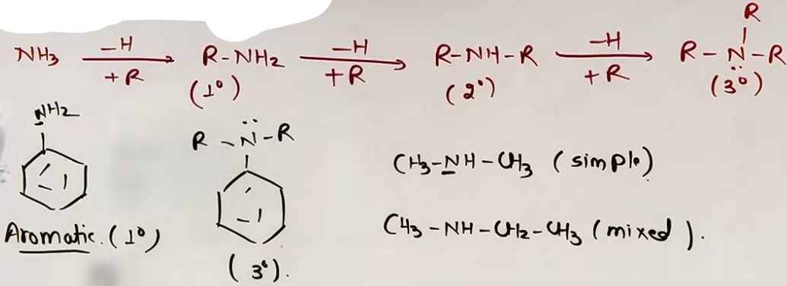
CLASSIFICATION BY DEGREE
Amines are classified as primary, secondary, or tertiary based on the number of hydrogen atoms replaced in the NH₃ molecule. This classification is unique compared to alcohols or alkyl halides, as it depends on the substitution of the Nitrogen atom itself.
+-----------+--------------+----------------+---------------+
| Degree | 1° (Primary) | 2° (Secondary) | 3° (Tertiary) |
+-----------+--------------+----------------+---------------+
| Structure | R-NH₂ | R-NH-R | R₃N |
+-----------+--------------+----------------+---------------+

Common Misconception: In Alcohols, a 2° alcohol is an -OH on a 2° carbon. In Amines, a 2° amine is NOT necessarily on a 2° carbon; it MUST have two carbon groups attached directly to the Nitrogen atom.

QUATERNARY AMMONIUM SALTS
Nitrogen has a lone pair of electrons even in 3° amines (R₃N:). If this lone pair is used to form a coordinate bond with another alkyl group (R), it forms a Quaternary Ammonium Salt.
General Formula: [R₄N]⁺ R⁻
In these salts, the nitrogen atom carries a formal positive charge and is bonded to four carbon groups.

ALIPHATIC VS. AROMATIC AMINES
Classification based on the nature of the groups attached to Nitrogen:

ALIPHATIC AMINES
The Nitrogen atom is attached to alkyl groups (open chains or non-aromatic rings).
Example: CH₃NH₂ (Methylamine).

AROMATIC AMINES
The Nitrogen atom is directly attached to one or more aromatic (aryl) rings.
Example: Aniline (C₆H₅NH₂), where the -NH₂ group is directly bonded to the benzene ring.
Classification within Aromatic:
- 1° Aromatic: Aniline (1 ring on N).
- 3° Aromatic: Triphenylamine (3 rings on N).

SIMPLE VS. MIXED AMINES
Secondary and tertiary amines can be further categorized based on the symmetry of the groups attached to the Nitrogen.
Type | Definition | Example
Simple (Symmetrical) | All alkyl or aryl groups on Nitrogen are the same. | CH₃)₂NH (Dimethylamine)
Mixed (Unsymmetrical) | The alkyl or aryl groups on Nitrogen are different. | CH₃-NH-C₂H₅ (Ethylmethylamine)

FORMULA SHEET
GENERAL STRUCTURES
- Ammonia: NH₃
- Primary Amine: RNH₂
- Secondary Amine: R₂NH
- Tertiary Amine: R₃N
- Quaternary Salt: R₄N⁺ X⁻

COMMON TRAPS
Mistake | Why Students Make It | Correct Thinking
Degree confusion | Thinking of carbon degrees | Count carbons on N, not the degree of the R-carbon.
Amine vs Amide | Seeing a C=O nearby | If Nitrogen is next to C=O, it is an Amide, not an Amine.
--------------------------------------------------------------------------------
ELECTRONIC STRUCTURE AND HYBRIDIZATION
AMINE DERIVATION AND HYBRIDIZATION
Amines are nitrogen-containing organic compounds derived from ammonia (NH₃). In any amine (whether primary, secondary, or tertiary), the nitrogen atom is sp³ hybridized. The electronic configuration of the nitrogen atom in this state involves four sp³ hybrid orbitals.

SUMMARY OF ELECTRONIC STATE
- Central Atom: Nitrogen (N).
- Steric Number: 3 Bond Pairs + 1 Lone Pair = 4.
- Hybridization: sp³.

GEOMETRY AND MOLECULAR SHAPE
IDEAL VS. ACTUAL GEOMETRY
According to the hybridization theory, four sp³ orbitals should ideally lead to a tetrahedral geometry. However, the molecular shape is defined only by the positions of the atoms (bond pairs), not the lone pair.

TRIGONAL PYRAMIDAL SHAPE
Because one of the four positions is occupied by a lone pair, the resulting molecular shape of an amine is Trigonal Pyramidal. The nitrogen atom sits at the apex of the pyramid, and the three attached groups (R or H) form the triangular base.
BOND ANGLE DEVIATION FROM IDEAL ANGLE
The ideal bond angle for a perfectly tetrahedral molecule (like CH₄) is 109.5°. In amines, the presence of the lone pair causes a deviation from this ideal angle. The bond angle in amines is always less than (<) 109.5°.

JEE ADVANCED INSIGHTS

LONE PAIR REACTIVITY
The lone pair is not just responsible for the shape; it is the reason amines behave as nucleophiles and bases. This lone pair is available for donation to electrophiles (like H⁺), leading to the formation of quaternary ammonium salts where the geometry finally becomes perfectly tetrahedral (as there are then 4 bond pairs and 0 lone pairs).

STERIC IMPACT ON ANGLES
While the lone pair reduces the angle, very bulky alkyl groups (like tertiary butyl groups) can push back against this "squeezing," sometimes causing the bond angle to increase slightly compared to simpler amines, though it typically remains near or below the ideal tetrahedral value.

HIGH-YIELD REVISION SHEET
MUST REMEMBER:
- Hybridization: sp³.
- Steric Number: 4 (3 Bond Pairs + 1 Lone Pair).
- Geometry: Tetrahedral.
- Shape: Trigonal Pyramidal.
- Bond Angle: Less than 109.5° (typically approx. 108°).

LAST-MINUTE REVISION POINTS:
- The lone pair occupies more space than a bond pair, leading to compressed bond angles.
- Nitrogen is at the apex of the pyramid.
- In quaternary ammonium salts (R₄N⁺), nitrogen is still sp³ but the shape is Tetrahedral and the angle is approx. 109.5°.

--------------------------------------------------------------------------------

METHOD OF PREPARATION OF AMINES

1. REDUCTION OF NITRO COMPOUNDS

Nitro compounds (R-NO₂) are reduced to primary amines (R-NH₂) by replacing oxygen atoms with hydrogen atoms. This is a straightforward and highly effective method for both aliphatic and aromatic amines.

REAGENTS AND CONDITIONS
* Catalytic Hydrogenation: H₂ in the presence of finely divided Palladium (Pd), Platinum (Pt), or Nickel (Ni).
* Chemical Reduction in Acidic Medium: Metal and concentrated Hydrochloric acid (HCl).
* Tin and HCl (Sn + HCl)
* Iron and HCl (Fe + HCl)

ADVANTAGE OF FE + HCL
This is the preferred industrial method. During the reaction, FeCl₂ is formed as a byproduct. FeCl₂ undergoes hydrolysis to release HCl back into the reaction mixture.
Fe + 2HCl → FeCl₂ + 2[H]
FeCl₂ + 2H₂O → Fe(OH)₂ + 2HCl
Because HCl is regenerated, only a small amount of initiatory acid is required, making the process economical.

SELECTIVE REDUCTION
When a molecule contains two nitro groups (dinitro compounds), selective reduction of only one nitro group can be achieved using specific reagents:
* Ammonium hydrogen sulphide: (NH₄)HS
* Ammonium sulphide: (NH₄)₂S
* H₂S in NH₃
This prevents both groups from reducing simultaneously, which would happen with stronger reagents like Sn + HCl or H₂/Pd.
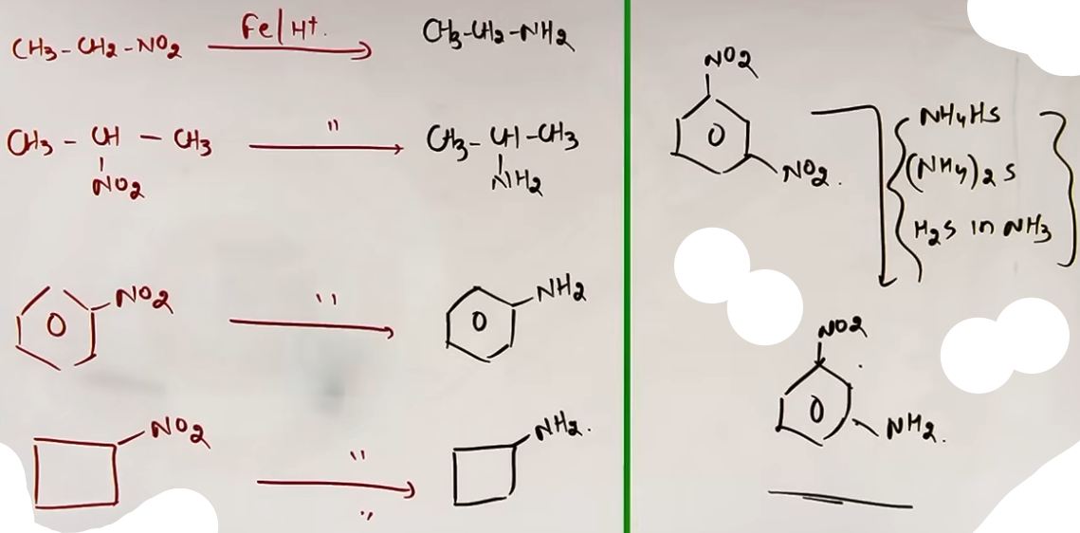
2. AMMONOLYSIS OF ALKYL HALIDES (HOFFMANN'S METHOD)
The reaction involves the cleavage of the Carbon-Halogen (C-X) bond by an ammonia molecule. It is a Nucleophilic Substitution reaction where Ammonia (NH₃) acts as the nucleophile.
Mechanism steps:
1. NH₃ attacks the electrophilic carbon of R-X, displacing the halide (X⁻).
2. A substituted ammonium salt is formed: [R-NH₃⁺ X⁻].
3. X⁻ attacks the hydrogen of amine, and R-NH₂ is formed with HX.

REACTION WITH EXCESS REAGENTS
* Excess Alkyl Halide: The reaction does not stop at the primary amine. Since the nitrogen in the resulting amine still has a lone pair, it continues to attack the excess R-X. This leads to a mixture of:
1° Amine → 2° Amine → 3° Amine → 4° Quaternary Ammonium Salt [R₄N⁺ X⁻].
* Excess Ammonia: If NH₃ is used in large excess, it ensures that every R-X molecule is attacked by NH₃ rather than the newly formed amine. This makes the Primary Amine (1°) the major product.
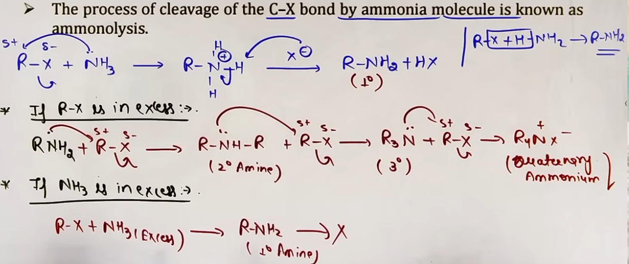
Imp points.
- Ammonolysis has the disadvantage of yielding a mixture of primary, secondary, tertiary and quaternary amines.
- However, primary amine is obtained as a major product by taking large excess of ammonia.
- The order of reactivity of halides with amines is R-I > R-Br > R-Cl and it is the order of rate of reaction.

3. REDUCTION OF NITRILES (CYANIDES)
Nitriles (R-CN) are reduced to primary amines containing the same number of carbon atoms. The -CN group is converted into a -CH₂NH₂ group.

REAGENTS
* Lithium Aluminium Hydride: LiAlH₄ in ether.
* Catalytic Hydrogenation: H₂/Ni, H₂/Pt, or H₂/Pd.
* Mendius Reaction: Sodium amalgam [Na(Hg)] in Ethanol (C₂H₅OH).

- This method is particularly useful for ascending the amine series (increasing chain length) if starting from an alkyl halide via cyanide substitution.
- Can only make 1° amines.

4. REDUCTION OF AMIDES
Amides (R-CONH₂) are reduced to amines with the same number of carbon atoms. The carbonyl group (C=O) is converted into a methylene group (CH₂).
Mechanism trick: Remove the oxygen and add two hydrogens to that carbon.

REAGENTS
* Reagent: LiAlH₄ followed by acidification H₃O⁺/H⁺.
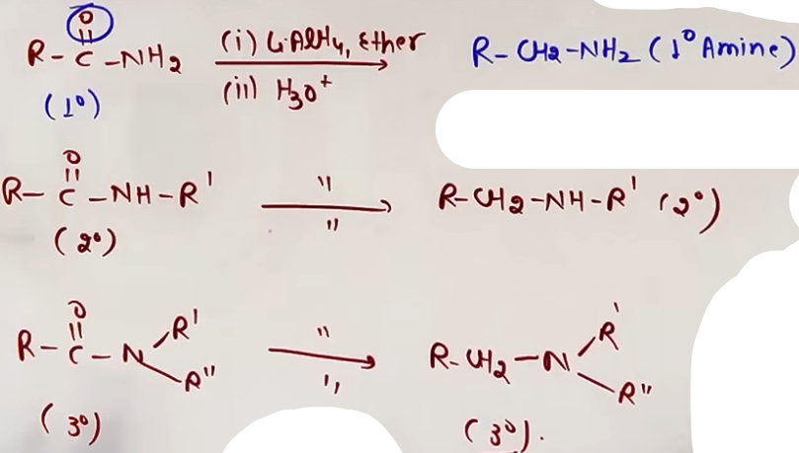
SPECIFIC EXAMPLES
* Acetamide (CH₃CONH₂) → Ethylamine (CH₃CH₂NH₂)
* Benzamide (C₆H₅CONH₂) → Benzylamine (C₆H₅CH₂NH₂).
Note: Unlike other methods, this can produce 1°, 2°, or 3° amines depending on the degree of the starting amide.

5. GABRIEL PHTHALIMIDE SYNTHESIS {V.V.Imp}
This is a specific method used for the preparation of pure 1° aliphatic amines.
Steps:
1. Phthalimide + KOH → Potassium Phthalimide (Salt).
2. Salt + R-X → N-Alkyl Phthalimide (Nucleophilic Substitution).
3. Hydrolysis with NaOH → 1° Amine (R-NH₂) + Sodium Phthalate.
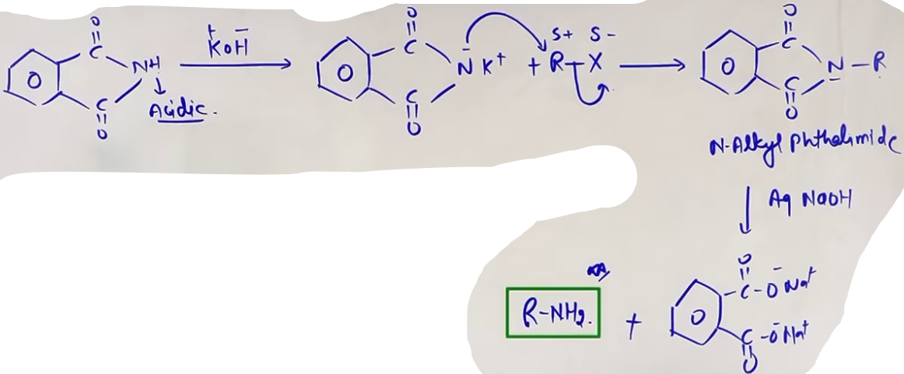
SPECIFICITY AND LIMITATIONS
* Only for 1° Aliphatic Amines: The step involving R-X is a nucleophilic substitution, if an 3° aliphatic halide is used elimination would occur in place of nucleophilic substitution.
* Aromatic Amine Limitation: Aromatic primary amines (like aniline) cannot be prepared by this method. This is because aryl halides (like Chlorobenzene) are inert toward nucleophilic substitution and will not react with the phthalimide salt.
# sirf aliphatic amines bana sakte h usme bhi sirf primary amine.

6. HOFFMANN BROMAMIDE DEGRADATION REACTION {V.V.V.V.V.Imp}
This reaction converts an amide (R-CONH₂) into a primary amine (R-NH₂) having one carbon atom less than the starting amide. It is a "degradation" because the carbon chain length is reduced.

REAGENTS
* Reagent: Br₂ + NaOH/KOH OR agar examiner jyada shara hoga toh NaOBr/KOBr.
* Active species: Sodium Hypobromite (NaOBr).
* NaOH Stoichiometry: 4 moles of NaOH per mole of Amide.

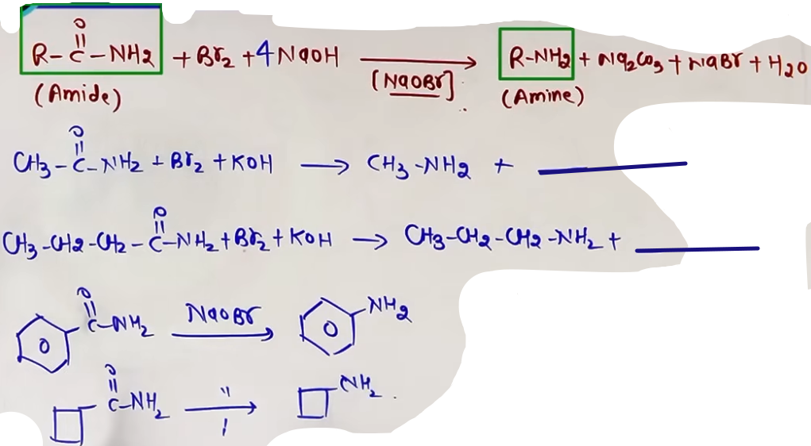

MECHANISM
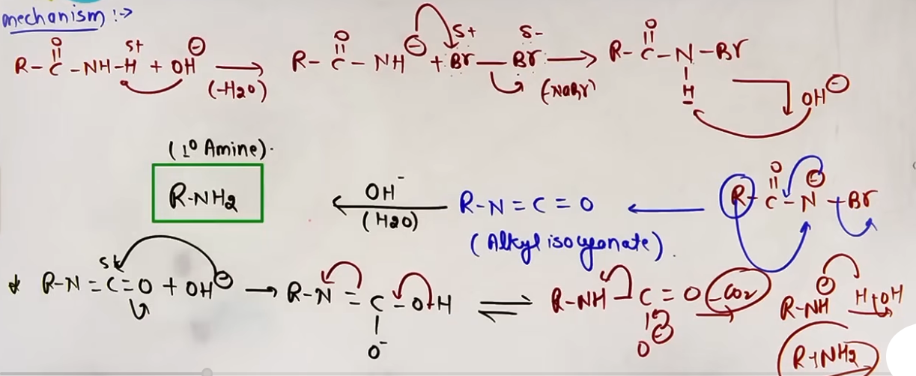
Intermediates formed -
1. N-bromoamide (R-CONHBr).
2. Alkyl Isocyanate (R-N=C=O).

---
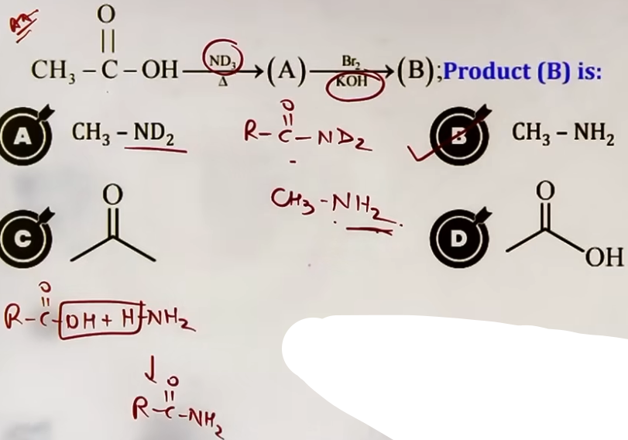# N k sath jo 2 hydrogen h vo solvent k h.
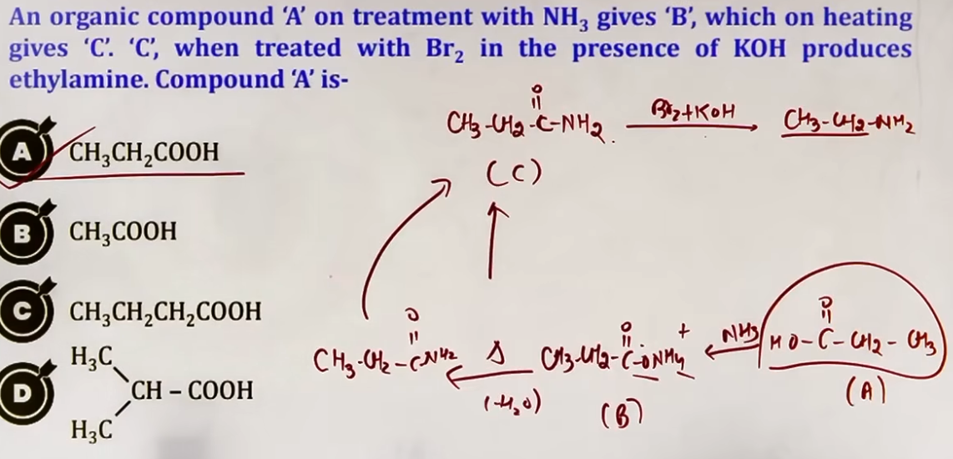
---
...[ Iske aage ki preparation methods not so important ]...

7. REDUCTION OF ISOCYANIDES (CARBYLAMINES)
- Reduction of Alkyl Isocyanides (R-NC) results in the formation of Secondary (2°) Amines.
R-NC + 4[H] → R-NH-CH₃
- Reducing agents used can be LiAlH₄ or H₂ with Pt/Pd/Ni
- The product is always a methyl-substituted secondary amine.

8. REDUCTION OF OXIMES
- Oximes (R-CH=N-OH) can be reduced to primary amines (1°) using Na/C₂H₅OH or LiAlH₄.
R-CH=N-OH → R-CH₂-NH₂.

9. REACTION OF AZIDES
Alkyl halides react with Sodium Azide (NaN₃) to form Alkyl Azides (R-N₃) via SN2 mechanism. Reduction of these azides with LiAlH₄ or H₂/Pd yields primary amines with the release of N₂ gas.
R-X + N₃⁻ → R-N₃ → R-NH₂ + N₂
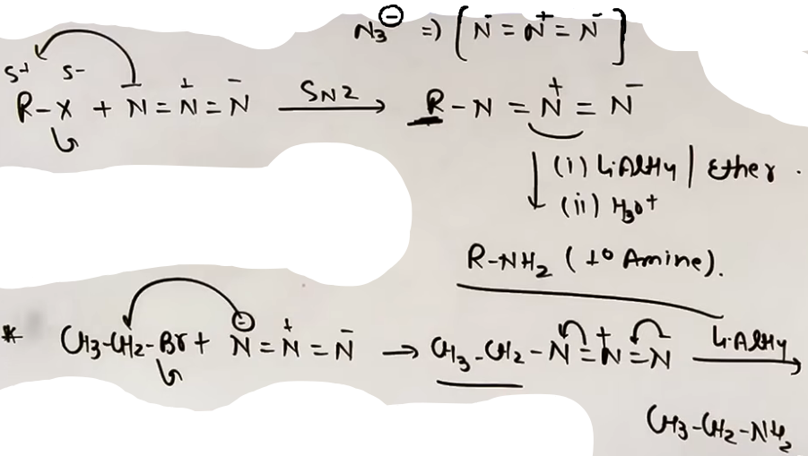

PROBLEM-SOLVING FRAMEWORK
Question Type | Identification Clues | Strategy / Approach
Carbon Loss | Amide + Br₂/NaOH | Hoffmann Degradation; remove >C=O.
Chain Ascent | R-X to R-CH₂NH₂ | R-X → R-CN → R-CH₂NH₂.
Pure 1° Amine | Phthalimide reagent | Gabriel Synthesis; product must be aliphatic.
2° Amine Prep | Isocyanide (R-NC) | Reduction yields R-NH-CH₃.
Selective Nitro | Dinitro compound | Use (NH₄)₂S to reduce only one NO₂.

HIGH-YIELD REVISION SHEET
MUST REMEMBER:
* Fe/HCl is best for Nitro reduction due to HCl regeneration.
* Hoffmann Degradation: Amide to Amine with ONE LESS CARBON.
* Gabriel Synthesis: NO Aromatic amines; ONLY 1° Aliphatic.
* Mendius Reaction: Na(Hg) + Ethanol for Nitrile reduction.
* Alkyl Isocyanate (R-N=C=O) is the key intermediate in Hoffmann Bromamide reaction.

COMMON TRAPS:
* Gabriel Synthesis: Aryl halides (like C₆H₅Cl) will NOT react; don't pick them for synthesis.
* Ammonolysis: Excess R-X gives a mixture; Excess NH₃ gives 1° Amine.
* 3° Alcohols/Alcohols with Cu: 3° alcohols yield alkenes, but in amines, 3° refers to N-substitution.
* Nitrile Reduction: Adds exactly one carbon to the original R-group.

--------------------------------------------------------------------------------
PHYSICAL PROPERTIES

SOLUBILITY IN WATER
Lower aliphatic amines are generally soluble in water due to their ability to form hydrogen bonds with water molecules.
* The nitrogen atom acts as a hydrogen bond acceptor (via its lone pair), while the hydrogen atoms attached to nitrogen act as hydrogen bond donors.
“Aromatic amines are insoluble in water.”

ROLE OF HYDROGEN BONDING
- In primary (1°) and secondary (2°) amines, the nitrogen-attached hydrogen atoms participate in H-bonding with the oxygen atom of H₂O.
- The lone pair on the nitrogen atom of all amines (1°, 2°, and 3°) can also form H-bonds with the hydrogen atoms of H₂O.
- Lower aliphatic amines are highly soluble in water because the extent of H-bonding is significant.

IMPACT OF HYDROPHOBIC ALKYL GROUPS
- Amines contain two parts: the polar amine group (-NH₂, -NH-, or -N-) and the non-polar alkyl group (R).
- As the size of the alkyl group or the molecular mass of the amine increases, the hydrophobic part dominates and solubility in water decreases as the number of carbon atoms in the alkyl chain increases.
- Higher amines (with many carbon atoms) are essentially insoluble in water but remain soluble in organic solvents like alcohol, ether, or benzene.

SOLUBILITY TREND: 1° > 2° > 3°
The solubility follows this order because of the availability of hydrogen atoms for H-bonding.

BOILING POINT
- The boiling point (BP) is directly proportional to the strength of intermolecular forces.
- Primary and secondary amines associate with each other via intermolecular hydrogen bonding.
- 3° Amines: Since there are no hydrogen atoms attached to the nitrogen, they cannot form intermolecular H-bonds, instead, 3° amines are held together only by weaker dipole-dipole or Van der Waals forces, leading to much lower boiling points.
BOILING POINT TREND: 1° > 2° > 3°

COMPARISON WITH ALCOHOLS AND ALKANES
When comparing compounds of similar molecular mass:
Alcohols > Amines > Alkanes
- Alkanes: Only weak London dispersion/Van der Waals forces.
- Amines: Intermolecular H-bonding exists.
- Alcohols: Stronger intermolecular H-bonding than amines.

HIGH-YIELD REVISION SHEET
SOLUBILITY TRENDS
- Solubility decreases as the carbon chain length increases.
- Solubility ∝ 1 / Molecular Mass (for same degree).
- Solubility ∝ 1 / Hydrophobic group size.
- General Order: 1° > 2° > 3°.
BOILING POINT TRENDS
- Boiling Point ∝ Strength of Intermolecular Forces.
- General Order: 1° > 2° > 3°.
- Alcohols have higher BP than Amines due to stronger O-H polarity.
- Global Comparison: Carboxylic Acids > Alcohols > Amines > Alkanes.

--------------------------------------------------------------------------------

CHEMICAL PROPERTIES

ELECTRONIC NATURE AND BASICITY

ELECTRONIC NATURE OF AMINES
Amines are reactive due to two primary electronic features:
1. The difference in electronegativity between Nitrogen and Hydrogen makes the N-H bond polar. Nitrogen carries a partial negative charge (δ⁻), and Hydrogen carries a partial positive charge (δ⁺).
2. The presence of an unshared non-bonding electron pair (lone pair) on the Nitrogen atom. This lone pair makes amines both nucleophilic (attacking electron-deficient centers) and basic (accepting protons).

BASIC NATURE AND SALT FORMATION {Imp}
- Amines are Lewis bases because they can donate their lone pair of electrons. - - They react with mineral acids (like HCl, H₂SO₄) to form water-soluble quaternary ammonium salts.
- Example: R-NH₂ + HCl ⇌ R-NH₃⁺ Cl⁻ (Ammonium salt).
- These salts can be converted back to the parent amine by treatment with a strong base like NaOH.

+-------------------------------------------------------+
| Basic Strength ∝ Stability of conjugate acid |
| Basic Strength ∝ Electron donating groups (EDG) |
| Basic Strength ∝ 1/Electron withdrawing groups (EWG) |
+-------------------------------------------------------+
| Basic Strength↑ ⇒ K_b↑ ⇒ pK_b↓ |
| pK_b = -log K_b. |
+-------------------------------------------------------+

BASICITY TRENDS
1. Aliphatic Amines vs. Ammonia: Aliphatic amines are stronger bases than ammonia due to the +I effect of alkyl groups.
2. Aliphatic vs. Aromatic Amines: Aliphatic amines are much stronger bases than aromatic amines (like Aniline). In aromatic amines, the Nitrogen lone pair is delocalized into the benzene ring via resonance, making it less available for protonation.
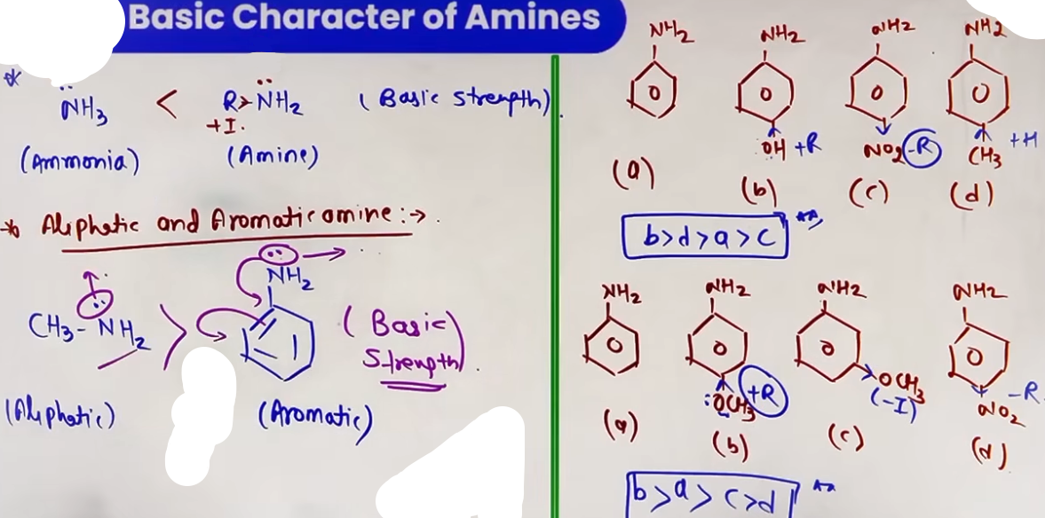
FACTORS AFFECTING BASICITY
1. Inductive Effect (+I): Alkyl groups (R) are electron-donating. They increase electron density on Nitrogen and stabilize the resulting conjugate acid (R-NH₃⁺) by dispersing the positive charge.
2. Solvation/Hydration Effect: In aqueous solution, the conjugate acid is stabilized by hydrogen bonding with water molecules. The more Hydrogen atoms attached to the Nitrogen in the conjugate acid, the greater the solvation.
3. Steric Hindrance(SIR effect): Bulky alkyl groups can obstruct the approach of a proton to the Nitrogen atom and interfere with the hydration of the resulting conjugate acid.
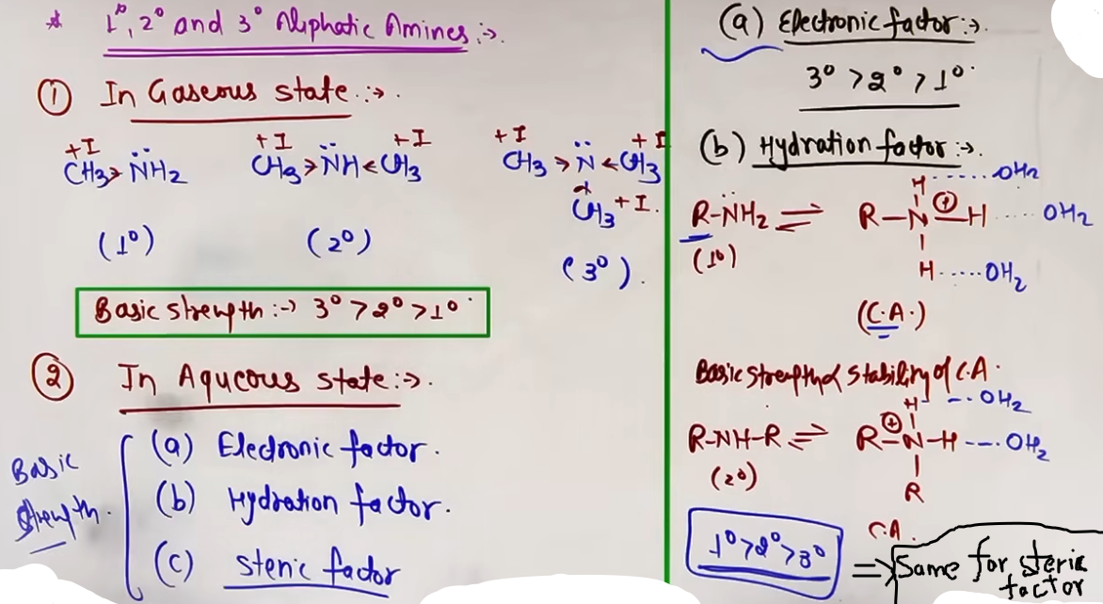
# gaseous state m order 3°>2°>1°
# aur aq. state m -
2°>1°>3° if R = methyl
2°>3°>1° if R = ethyl
# yaad hi karna padega :) 213 aur 231
# kuch nahi bola toh gas manna h

FORMULA SHEET
RELATIONSHIP SUMMARY
- Basic Strength ∝ K_b
- Basic Strength ∝ 1 / pK_b
- Basic Strength ∝ Stability of Conjugate Acid
- pK_b = -log K_b

GAS PHASE BASICITY ORDER (PURE INDUCTIVE EFFECT)
3° Amine > 2° Amine > 1° Amine > NH₃

AQUEOUS PHASE BASICITY ORDERS
- If R = Methyl (CH₃): 2° > 1° > 3° > NH₃ (Order: 213)
- If R = Ethyl (C₂H₅): 2° > 3° > 1° > NH₃ (Order: 231)

CONCEPT CONNECTIONS
Comparison | Basic Strength | Reasoning
R-NH₂ vs NH₃ | R-NH₂ > NH₃ | +I effect of R-group
Aliphatic vs Aromatic | Aliphatic > Aromatic | Resonance delocalization in aromatic
Aniline vs Benzylamine | Benzylamine > Aniline | Benzylamine's LP is not in resonance
JEE ADVANCED INSIGHTS
ORTHO EFFECT AND SIP (STERIC INHIBITION OF PROTONATION)
In ortho-substituted anilines, the basicity is significantly lower than in aniline, regardless of whether the group is EDG or EWG.
- Reason: When the Nitrogen is protonated to form Ar-NH₃⁺, the bulky ortho group creates steric repulsion with the incoming protons/water of hydration.
- Result: The conjugate acid becomes unstable, making the ortho-substituted amine a very weak base.

SIR (STERIC INHIBITION OF RESONANCE)
Observed in N,N-Dimethylaniline with bulky ortho substituents.
- Normal Case: Nitrogen lone pair is in resonance with the ring (Low basicity).
- SIR Case: Bulky ortho groups push the -N(CH₃)₂ group out of the ring's plane.
- Result: Resonance is blocked. The lone pair stays localized on Nitrogen, making it a MUCH stronger base (approaching aliphatic levels).

HIGH-YIELD REVISION SHEET
MUST REMEMBER
- Gas Phase Order: 3° > 2° > 1° > NH₃ (Inductive effect only).
- Aqueous Methyl: 2° > 1° > 3° (213).
- Aqueous Ethyl: 2° > 3° > 1° (231).
- Aliphatic > NH₃ > Aromatic.
- EDG increases basicity; EWG decreases basicity.
- pK_b = -log K_b (Smaller pK_b = Stronger base).
LAST-MINUTE REVISION POINTS
- SIP (Ortho Effect) makes ortho-substituted anilines weak bases.
- SIR (Steric Inhibition of Resonance) makes 3° aromatic amines with ortho groups strong bases by localized LP.
- 1° aliphatic amines + Nitrous Acid (HNO₂) → Alcohols + N₂ gas.
- Aniline + HNO₂ (0-5°C) → Stable Diazonium Salt.
- Friedel-Crafts reaction fails for Aniline because the Lewis acid (AlCl₃) forms a salt with the basic Nitrogen.
--------------------------------------------------------------------------------
CHEMICAL PROPERTIES

NUCLEOPHILIC REACTIONS OF AMINES

ALKYLATION OF AMINES
Amines act as nucleophiles due to the presence of a lone pair of electrons on the nitrogen atom. They react with alkyl halides (R-X) via a nucleophilic substitution (SN2) mechanism.
- In this reaction, the hydrogen atoms of the amine are successively replaced by alkyl groups.
- If the alkyl halide is in excess, the reaction proceeds from a primary (1°) amine to a secondary (2°) amine, then to a tertiary (3°) amine, and finally to a quaternary ammonium salt ([R₄N]⁺ X⁻).
- This process is also known as Hoffmann's ammonolysis of alkyl halides.
# pehle kar chuke h issi chapter m ‘ammonolysis’
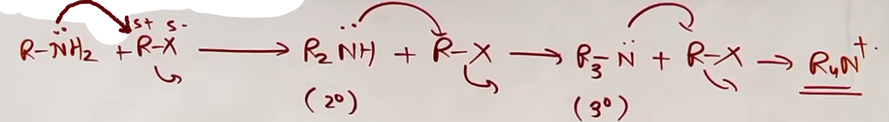
ACYLATION (ACETYLATION)
Aliphatic and aromatic primary and secondary amines react with acid chlorides, anhydrides, or esters to form amides. This reaction is a nucleophilic acyl substitution.
- Mechanism: Nucleophilic Addition-Elimination.
1. The nitrogen lone pair attacks the carbonyl carbon (Addition).
2. A tetrahedral intermediate is formed.
3. The leaving group (e.g., Cl⁻ or carboxylate ion) is expelled, and a proton is lost to restore the carbonyl group (Elimination).
- The reaction is carried out in the presence of a base stronger than the amine, such as Pyridine.
- Purpose of Pyridine: It removes the HCl formed during the reaction, shifting the equilibrium to the right (forward direction) and preventing the amine from forming an unreactive salt with the acid.
- Note: Tertiary (3°) amines do not undergo acylation because they lack a replaceable hydrogen atom on the nitrogen.
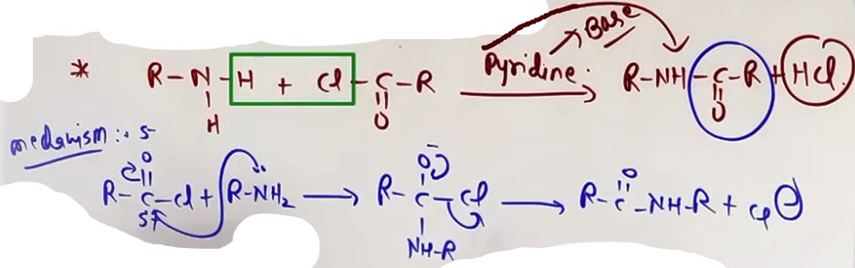
BENZOYLATION (SCHOTTEN-BAUMANN REACTION)
When amines are reacted specifically with Benzoyl Chloride (C₆H₅COCl) in the presence of a base (like NaOH or Pyridine), the reaction is known as the Schotten-Baumann reaction.
- Example: CH₃NH₂ + C₆H₅COCl + NaOH → C₆H₅CONHCH₃ + NaCl + H₂O.
# same h uppar wale ke tarah :) acylation ka hi part h

CARBYLAMINE REACTION (ISOCYANIDE TEST) {Imp}
This is a specific diagnostic test used to identify primary amines.
“R-NH₂ + CHCl₃ -–{Alc. KOH}--> R-NC + H₂O + KCL”
- Requirement: Only 1° aliphatic and 1° aromatic amines give this reaction.
- Reagents: Chloroform (CHCl₃) and Alcoholic Potassium Hydroxide (KOH).
- Product: An Isocyanide or Carbylamine (R-NC), which is characterized by an extremely offensive, foul, or unpleasant smell.
- Intermediate: The reaction proceeds via the formation of Dichlorocarbene (:CCl₂), which acts as a neutral electrophile.
- Note: Secondary (2°) and tertiary (3°) amines do not give this test, making it a reliable method for distinguishing primary amines from others.
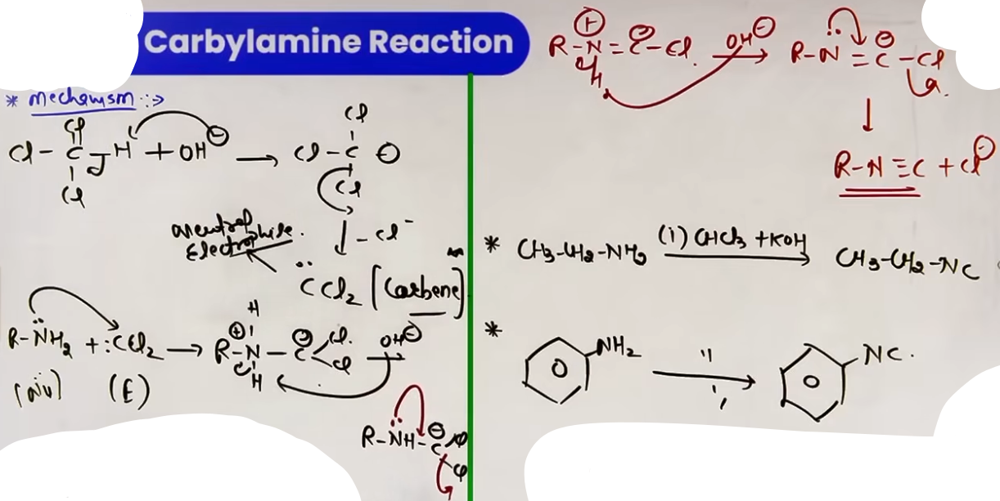

---
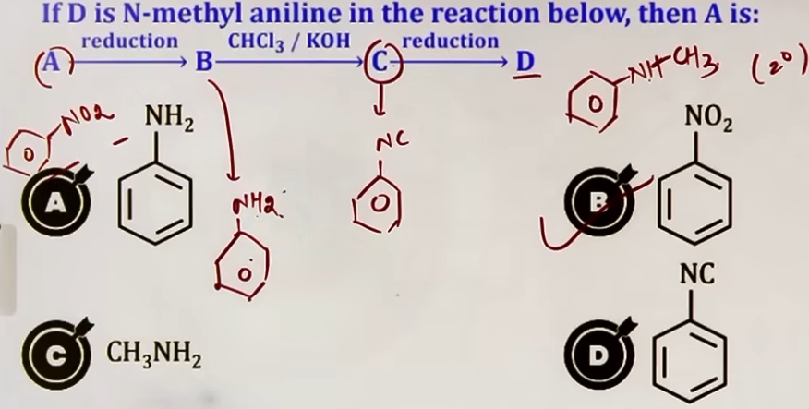
---

INTUITION AND CONCEPTUAL UNDERSTANDING
Visualize the nitrogen atom as a ship's dock. The lone pair is the "crane" that reaches out to grab "cargo" (alkyl or acyl groups).
- In Alkylation: The crane keeps grabbing more alkyl groups as long as there is "space" (hydrogens to replace). Even when the space is full (3° amine), the crane (lone pair) is so strong it can grab one last group to form a salt.
- In Acylation: The crane grabs a bulky "shield" (the acyl group). Once this shield is on, the nitrogen is less nucleophilic because the lone pair is now busy in resonance with the new carbonyl group.
- In Carbylamine: It is like a chemical "fire alarm." Only 1° amines have the specific structure to create the "foul-smelling" isocyanide molecule. If you smell something terrible after adding CHCl₃ and KOH, your "1° Amine alarm" is going off.

FORMULA SHEET

ALKYLATION SEQUENCE
R-NH₂ + R'-X → R-NH-R' + HX (2° Amine)
R-NH-R' + R'-X → R-N(R')₂ + HX (3° Amine)
R-N(R')₂ + R'-X → [R-N(R')₃]⁺ X⁻ (Quaternary Salt)

ACYLATION REACTION
R-NH₂ + R'COCl (Pyridine) → R-NH-COR' + HCl
R-NH₂ + (CH₃CO)₂O → R-NH-COCH₃ + CH₃COOH

CARBYLAMINE REACTION
R-NH₂ + CHCl₃ + 3KOH (alc.) --heat--> R-NC + 3KCl + 3H₂O
(Product R-NC = Alkyl Isocyanide / Carbylamine)

CONCEPT CONNECTIONS
Reaction | Linked Concept / Topic | Significance
Acylation | Protection of Amines | Used in EAS to reduce the activating power of -NH₂.
Carbylamine | Reimer-Tiemann Reaction | Both share the :CCl₂ (Dichlorocarbene) intermediate.
Alkylation | SN2 Mechanism | Follows reactivity order of halides: RI > RBr > RCl.
Acylation | Nucleophilic Acyl Sub. | Reactivity: Acid Chloride > Anhydride > Ester.
JEE ADVANCED INSIGHTS
- DICHLOROCARBENE INTERMEDIATE
In the Carbylamine reaction, KOH reacts with CHCl₃ to produce :CCl₂ via alpha-elimination. This :CCl₂ is an electron-deficient species (electrophile) that is attacked by the nucleophilic nitrogen of the 1° amine.
- STERIC HINDRANCE IN ACYLATION
While 1° and 2° amines react, the rate of acylation decreases significantly as the groups on the nitrogen or the acylating agent become bulkier. This is a typical Nucleophilic Addition-Elimination trend where the tetrahedral intermediate becomes harder to form.
- SELECTIVE ACYLATION
If a molecule has both an -OH and an -NH₂ group, the -NH₂ group is typically acylated first because nitrogen is more nucleophilic than oxygen.

HIGH-YIELD REVISION SHEET
MUST REMEMBER:
- Carbylamine Test = 1° Amines only + CHCl₃ + KOH → R-NC (Foul smell).
- Intermediate in Carbylamine = Dichlorocarbene (:CCl₂).
- Acylation uses Pyridine to "clean up" HCl.
- 3° Amines = No Acylation.
- Alkylation with excess R-X leads to Quaternary Ammonium Salts.
- Benzoylation name = Schotten-Baumann Reaction.
LAST-MINUTE REVISION POINTS:
- R-NC is the product of Carbylamine, NOT R-CN.
- Isocyanide smell is described as "offensive" or "foul."
- Acylation is a Nucleophilic Addition-Elimination reaction.
- Pyridine is a base that is stronger than the reactant amine.
- 1° Aromatic amines (Aniline) DO give the Carbylamine test.
--------------------------------------------------------------------------------

REACTIONS WITH NITROUS ACID(HNO₂) {Diazotization} {Imp}
REAGENT PREPARATION
- Nitrous acid (HNO₂) is highly unstable and cannot be stored. It must be prepared in-situ (freshly during the reaction).
- Reagent: Sodium Nitrite (NaNO₂) and concentrated Hydrochloric Acid (HCl).
- Reaction: NaNO₂ + HCl -> HNO₂ + NaCl
- Temperature: Generally maintained at 0 to 5 degrees Celsius (273 to 278 K) to prevent decomposition.
- Active Electrophile: Nitrosonium ion (NO⁺), generated from HNO₂ in acidic medium.

DIAZOTIZATION OF PRIMARY AROMATIC AMINES
- Primary aromatic amines (like Aniline) react with nitrous acid at low temperatures to form stable arenediazonium salts.
- Reaction: C₆H₅NH₂ + NaNO₂ + 2HCl (at 0-5°C) -> C₆H₅N₂⁺ Cl⁻ + NaCl + 2H₂O
- Product: Benzene Diazonium Chloride.
- Stability: These salts are stable in the 0-5°C range because the diazonium group (-N₂⁺) is stabilized by resonance with the benzene ring. If the temperature rises above 5°C, they decompose to form Phenol and release N₂ gas.
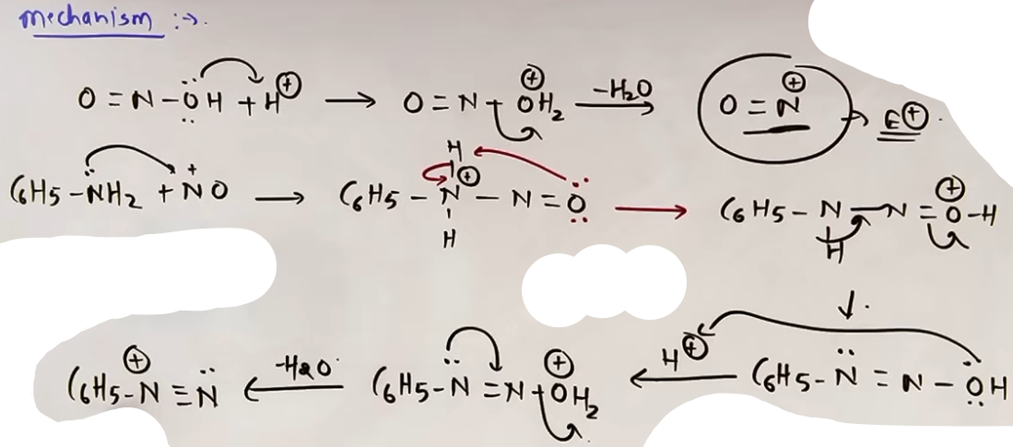
REACTION OF PRIMARY ALIPHATIC AMINES
- Primary aliphatic amines react with nitrous acid to form highly unstable aliphatic diazonium salts.
- Reaction: R-NH₂ + HNO₂ -> [R-N₂⁺ Cl⁻] (unstable)
- Process: The unstable salt immediately decomposes to release Nitrogen gas (N₂) and forms a carbocation (R⁺).
- Outcome: The carbocation typically reacts with water (from the medium) to form an Alcohol.
- Important: Since a carbocation is formed as an intermediate, rearrangement (1,2-hydride or methyl shift) can occur to form a more stable product.
- Reaction Trend: R-NH₂ + HNO₂ -> R-OH + N₂ + H₂O

REACTION OF SECONDARY AMINES (ALIPHATIC AND AROMATIC)
- Secondary amines react with nitrous acid to form N-nitrosoamines.
- Reaction: R₂NH + HNO₂ -> R₂N-N=O + H₂O
- Observation: N-nitrosoamines are insoluble in the reaction medium and appear as a Yellow Oily Layer.
- This reaction is characteristic of both aliphatic and aromatic secondary amines (e.g., N-methylaniline).
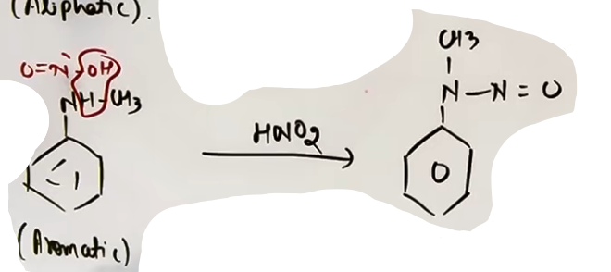
# HNO2 ko aise rakhko ke pani nikale ::) hamesha.

REACTION OF TERTIARY AMINES
1. ALIPHATIC TERTIARY AMINES
- Tertiary aliphatic amines lack a replaceable hydrogen on the nitrogen. They react with nitrous acid to form soluble trialkylammonium nitrite salts.
- Reaction: R₃N + HNO₂ -> [R₃NH]⁺ NO₂⁻
- This is a simple acid-base reaction forming a water-soluble salt.

2. AROMATIC TERTIARY AMINES (E.G., N,N-DIMETHYLANILINE)
- Aromatic tertiary amines undergo Electrophilic Aromatic Substitution (EAS) because the nitrogen lone pair is involved in resonance, activating the ring.
- Mechanism: The Nitrosonium ion (NO⁺) attacks the para position of the aromatic ring.
- Product: Para-nitroso product (e.g., p-Nitroso-N,N-dimethylaniline).
- Note: If the para position is blocked, the substitution occurs at the ortho position, though it is less favorable due to steric hindrance.
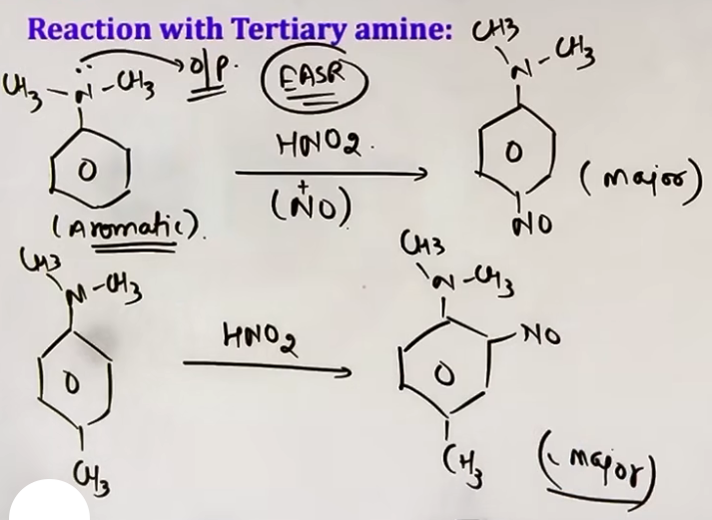
INTUITION AND CONCEPTUAL UNDERSTANDING

THE RESONANCE STABILIZATION DIVIDE
Think of the -N₂⁺ group as a "ticking time bomb" that wants to release N₂ gas.
- In Aliphatic Amines: There is nothing to hold the bomb. It explodes immediately, leaving a "crater" (carbocation). This explains why we see N₂ bubbles and form alcohols.
- In Aromatic Amines: The benzene ring "holds" the group through resonance. This "grip" is only strong enough at freezing temperatures (0-5°C). As soon as the temperature rises, the ring loses its grip, and the bomb goes off (releasing N₂ and forming Phenol).

VISUALIZING THE YELLOW OILY LAYER
For 2° amines, the reaction stops halfway because the nitrogen has no more hydrogens to lose. The resulting N-nitroso compound is non-polar compared to the salt/medium, which is why it separates out as a distinct yellow oil.

FORMULA SHEET

1° ALIPHATIC: R-NH₂ + HNO₂ -> R-OH + N₂ (gas) + H₂O
1° AROMATIC: C₆H₅NH₂ + HNO₂ + HCl (0-5°C) -> C₆H₅N₂⁺ Cl⁻ + 2H₂O
2° (ALIPHATIC/AROMATIC): R₂NH + HNO₂ -> R₂N-NO (Yellow Oil) + H₂O
3° ALIPHATIC: R₃N + HNO₂ -> [R₃NH]⁺ NO₂⁻ (Soluble Salt)
3° AROMATIC: Ar-NR₂ + HNO₂ -> O=N-Ar-NR₂ (p-nitroso substitution)

CONCEPT CONNECTIONS

Amine Type | Immediate Product | Visual Observation | Link to other topics
1° Aliphatic | Alcohol | N₂ gas bubbles | Carbocation Rearrangement
1° Aromatic | Diazonium Salt | Clear Solution | Sandmeyer/Coupling rxn
2° Both | Nitrosoamine | Yellow oily layer | Lieberman Nitroso Test
3° Aliphatic | Nitrite Salt | Clear Solution | Acid-Base Chemistry
3° Arom | Para-nitroso | Colored product | EAS Reactions

EXAMPLES AND APPLICATIONS

EXAMPLE 1: PROPAN-1-AMINE + HNO₂
1. Formation of CH₃CH₂CH₂-N₂⁺ (Unstable).
2. Loss of N₂ forms 1° Carbocation: CH₃CH₂CH₂⁺.
3. 1,2-Hydride shift forms 2° Carbocation: CH₃-CH⁺-CH₃.
4. Product: Propan-2-ol (Major) and Propan-1-ol (Minor).

EXAMPLE 2: ANILINE AT 0°C VS 25°C
At 0°C: Benzene Diazonium Chloride (C₆H₅N₂⁺ Cl⁻) is formed.
At 25°C: The diazonium salt decomposes. Phenol (C₆H₅OH) and N₂ gas are formed.

JEE ADVANCED INSIGHTS

THE ELECTROPHILE (NO⁺)
The nitrosating species is the Nitrosonium ion (NO⁺). In the reaction between a 1° amine and NO⁺, the Rate Determining Step (RDS) is typically the nucleophilic attack of the amine on the NO⁺ ion or the subsequent proton shifts depending on conditions.

EAS ON 3° AROMATIC AMINES
For N,N-Dimethylaniline, the Nitrosonium ion is a weak electrophile. It can only attack highly activated rings (like those with -NH₂, -OH, or -NR₂). This is why it specifically targets the para position of aromatic amines, providing a green-colored p-nitroso derivative.

HIGH-YIELD REVISION SHEET
MUST REMEMBER
- 1° Aliphatic -> Alcohol + N₂ bubbles (Carbocation rearrangement possible).
- 1° Aromatic -> Diazonium salt (Stable ONLY at 0-5°C).
- 2° (Any) -> Yellow Oily Layer (Nitrosoamine).
- 3° Aliphatic -> Clear soluble salt.
- 3° Aromatic -> Para-nitroso product (EAS).
- Reagent NaNO₂ + HCl generates HNO₂ in-situ.

LAST-MINUTE REVISION POINTS
- The evolution of N₂ gas is a diagnostic test for 1° aliphatic amines.
- Benzene diazonium salts are essential intermediates for Sandmeyer and Coupling reactions.
- Only the 2° amine gives the "Yellow Oily Layer" observation.
- If para is blocked in a 3° aromatic amine, NO⁺ goes to the ortho position.
--------------------------------------------------------------------------------

HINSBERG TEST
Hinsberg Test is a chemical method used to distinguish between primary (1°), secondary (2°), and tertiary (3°) amines. It can also be used for the separation of a mixture of these amines.

HINSBERG REAGENT
The reagent used is Benzene Sulphonyl Chloride. Its chemical formula is C₆H₅SO₂Cl.

REACTION MECHANISM
The reaction is a nucleophilic substitution. The lone pair of the amine nitrogen attacks the sulfur atom of the benzene sulphonyl chloride, displacing the chloride ion (Cl⁻).

REACTION WITH 1° AMINES
- A primary amine reacts with benzene sulphonyl chloride to form N-alkyl benzene sulphonamide.
- The resulting product contains one acidic hydrogen atom attached directly to the nitrogen atom.
- The strong electron-withdrawing nature of the sulphonyl group (-SO₂-) makes this hydrogen highly acidic.
- Because of this acidic hydrogen, the product is soluble in alkali (like NaOH or KOH).
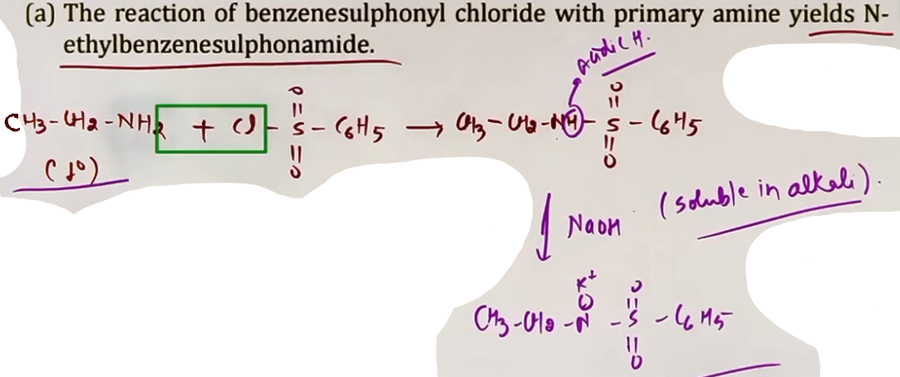
REACTION WITH 2° AMINES
- A secondary amine reacts with benzene sulphonyl chloride to form N,N-dialkyl benzene sulphonamide.
- The resulting product has no hydrogen atom attached to the nitrogen atom.
- Therefore, the product is not acidic and is insoluble in alkali. It usually appears as a precipitate.
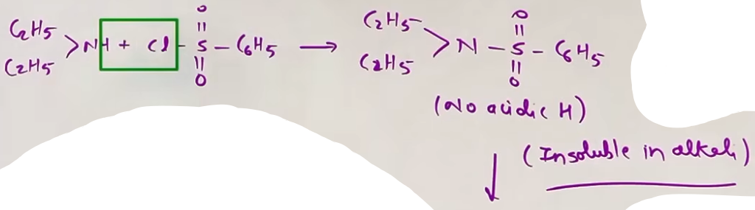
REACTION WITH 3° AMINES
Tertiary amines do not have any replaceable hydrogen atoms on the nitrogen atom.
Consequently, tertiary amines do not react with benzene sulphonyl chloride.

INTUITION AND CONCEPTUAL UNDERSTANDING
THE ACIDIC HYDROGEN KEY
- The entire test relies on whether the nitrogen atom in the final product still holds a "spare" hydrogen.
- In a 1° amine (R-NH₂), two hydrogens are available. One is lost to remove the - Chlorine, and one remains on the Nitrogen. This remaining hydrogen is "squeezed" by the powerful -SO₂- group, making it easy to pop off as an H⁺ (acidic). This allows the molecule to dissolve in a base.
- In a 2° amine (R₂NH), only one hydrogen is available. It is used up in the reaction to remove the Chlorine. The nitrogen is left "bare" of hydrogens, so it cannot interact with a base.

FORMULA SHEET

HINSBERG REAGENT: C₆H₅SO₂Cl

1° AMINE REACTION:
C₆H₅SO₂Cl + R-NH₂ → C₆H₅SO₂NH-R + HCl
(Product + NaOH → Soluble Salt)

2° AMINE REACTION:
C₆H₅SO₂Cl + R₂NH → C₆H₅SO₂N(R)₂ + HCl
(Product + NaOH → Insoluble/No change)

3° AMINE REACTION:
C₆H₅SO₂Cl + R₃N → No Reaction

CONCEPT CONNECTIONS
+--------------------------+--------------+-----------+----------+
| Comparison Point | 1° Amine | 2° Amine | 3° Amine |
+--------------------------+--------------+-----------+----------+
| Reaction with C₆H₅SO₂Cl | Yes | Yes | No |
| Hydrogens on Product N | One (Acidic) | Zero | N/A |
| Behavior in NaOH | Soluble | Insoluble | N/A |
+--------------------------+--------------+-----------+----------+

JEE ADVANCED INSIGHTS
SEPARATION OF MIXTURES
This test is not just for identification but for physical separation.
If you have a mixture of 1°, 2°, and 3° amines:
1. Add Hinsberg Reagent.
2. 3° amine remains unreacted.
3. Add alkali. 1° amine product dissolves, 2° amine product stays as a precipitate.
4. Filter to remove 2° product.
5. Distill to recover 3° amine.
6. Acidify the filtrate to recover the 1° amine product.
HIGH-YIELD REVISION SHEET
MUST REMEMBER:
- Reagent: Benzene Sulphonyl Chloride (C₆H₅SO₂Cl).
- 1° Amine: Reacts → Soluble in NaOH.
- 2° Amine: Reacts → Insoluble in NaOH.
- 3° Amine: No Reaction.

LAST-MINUTE REVISION POINTS:
- The product of 1° amine is soluble because of the acidic H on Nitrogen.
- The -SO₂- group is a strong electron-withdrawing group that creates this acidity.
- This test effectively separates or distinguishes 1°, 2°, and 3° amines.
- Tertiary amines lack a replaceable H, which is why they don't react.

--------------------------------------------------------------------------------

ELECTROPHILIC AROMATIC SUBSTITUTION REACTION {Imp}

ACTIVATION AND DIRECTING INFLUENCE
- The -NH₂ group is a very strong activating group for electrophilic aromatic substitution (EAS).
- This is because the lone pair of electrons on the nitrogen atom is in direct resonance with the benzene ring, significantly increasing the electron density at the ortho and para positions.
- Nitrogen is less electronegative than Oxygen, making its lone pair more available for donation compared to the -OH group in phenol.
- Consequently, aromatic amines like aniline are highly reactive towards electrophiles and are exclusively ortho-para directing.

BROMINATION
- When aniline is treated with bromine water (Br₂/H₂O) at room temperature, it undergoes immediate and multiple substitutions.
- All available ortho and para positions are occupied, resulting in the formation of 2,4,6-tribromoaniline. # as in phenol
- Observation: This product appears as a distinct white precipitate.

MONOBROMINATION STRATEGY (PROTECTION)
- Because the -NH₂ group is so reactive, it is difficult to stop the reaction at the mono-substitution stage.
- To obtain a mono-substituted product (like para-bromoaniline), the activating power of the -NH₂ group must be decreased.
- This is achieved through acetylation (protection) using acetic anhydride [(CH₃CO)₂O] in the presence of pyridine.
- The reaction forms acetanilide (C₆H₅NHCOCH₃).
- In acetanilide, the nitrogen lone pair is involved in cross-conjugation with the carbonyl group, making it less available for the ring.
- After bromination of acetanilide, the acetyl group is removed via acidic or basic hydrolysis to regenerate the amine group, yielding the para-bromoaniline as the major product.
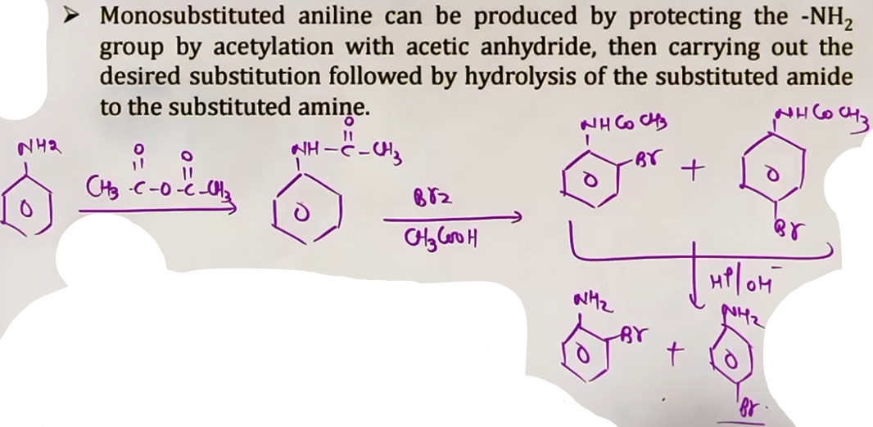
NITRATION ANOMALY
- Direct nitration of aniline with a mixture of concentrated HNO₃ and H₂SO₄ leads to a surprising result, instead of just ortho and para products, an appreciable amount of the meta product is formed.
- Composition: Para-nitroaniline (51%), Meta-nitroaniline (47%), and Ortho-nitroaniline (2%).
- Reason: In the strongly acidic nitrating medium, the basic aniline molecule is protonated to form the anilinium ion (C₆H₅-NH₃⁺).
- The -NH₃⁺ group is a strong electron-withdrawing group and is meta-directing.
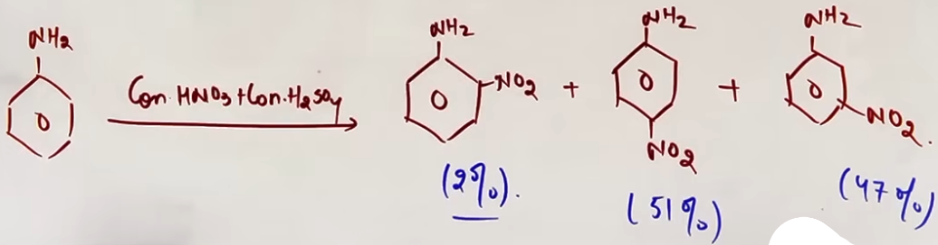
- To obtain the para product as major, aniline is first protected by acetylation, then nitrated, and finally hydrolyzed. #davai vo hi h jo pehle thi
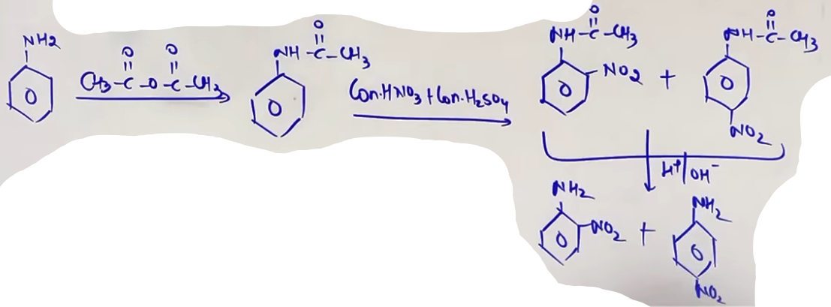
SULPHONATION
- Aniline reacts with concentrated H₂SO₄ to initially form a salt called anilinium hydrogen sulphate.
- When this salt is heated to 453-473 K, it undergoes a rearrangement to form p-aminobenzene sulphonic acid, commonly known as sulphanilic acid.
- Sulphanilic acid contains both a basic (-NH₂) group and an acidic (-SO₃H) group within the same molecule, therefore it exists in an equilibrium as a dipolar ion known as a Zwitterion [(⁺NH₃)-C₆H₄-(SO₃⁻)].
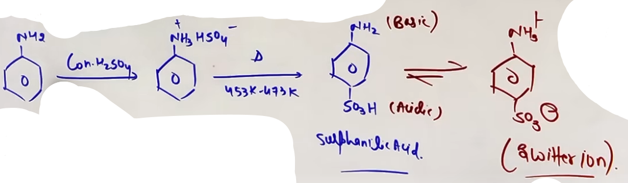

FRIEDEL-CRAFTS REACTION FAILURE
- Aniline and other aromatic amines do not undergo Friedel-Crafts alkylation or acylation.
- Reason: The Lewis acid catalyst used in the reaction (AlCl₃) is an electrophile, while the -NH₂ group is a Lewis base, They react immediately to form a salt.
- The nitrogen atom in the salt carries a positive charge (C₆H₅NH₂⁺-AlCl₃⁻), which makes it a strong deactivating group, preventing any further EAS from occurring.

FORMULA SHEET

BROMINATION
Reaction: C₆H₅NH₂ + 3Br₂ (aq) -> C₆H₂Br₃NH₂ (2,4,6-tribromoaniline) + 3HBr
Observation: White Precipitate

NITRATION PRODUCT DISTRIBUTION
- Para (Major): 51%
- Meta (Significant): 47%
- Ortho (Minor): 2%

SULPHONATION AND ZWITTERION
Aniline + H₂SO₄ (conc.) -> C₆H₅NH₃⁺ HSO₄⁻ --(453-473 K)--> NH₂-C₆H₄-SO₃H
Zwitterion: ⁺NH₃-C₆H₄-SO₃⁻

PROTECTION REACTION
C₆H₅NH₂ + (CH₃CO)₂O --(Pyridine)--> C₆H₅NHCOCH₃ (Acetanilide)

CONCEPT CONNECTIONS
+---------------+--------------+----------------+------------------------------+
| Reaction Type | Reagent | Aniline Result | Reason |
+---------------+--------------+----------------+------------------------------+
| Bromination | Br₂/H₂O | 2,4,6-Tribromo | High activation |
| Nitration | HNO₃/H₂SO₄ | 47% Meta | Anilinium ion formation |
| Sulphonation | H₂SO₄ (heat) | Zwitterion | Acid-Base internal reaction |
| Friedel-Crafts| R-Cl/AlCl₃ | No Reaction | Salt formation with catalyst |
+---------------+--------------+----------------+------------------------------+

HIGH-YIELD REVISION SHEET
MUST REMEMBER:
- Aniline + Br₂ (aq) = White ppt (2,4,6-tribromo).
- Nitration gives 47% Meta because of -NH₃⁺.
- Protection = Acetylation (use acetic anhydride and pyridine).
- Sulphanilic acid exists as a Zwitterion.
- Friedel-Crafts fails due to salt formation with AlCl₃.

LAST-MINUTE REVISION POINTS:
- Temperature for Sulphonation: 453 to 473 K.
- The protective group is NHCOCH₃ (Acetanilide).
- Order of reactivity: Aniline > Benzene > Nitrobenzene.
- Hydrolysis is needed to "unprotect" the amine.

--------------------------------------------------------------------------------

DIAZONIUM SALTS

- Diazonium salts are a class of organic compounds with the general formula:
Ar-N₂⁺ X⁻.
Ar represents an aryl group (aromatic ring), and X⁻ is an anion such as Cl⁻, Br⁻, HSO₄⁻, BF₄⁻, etc.
- The N₂⁺ group is called the diazonium group.

STABILITY AND RESONANCE
- Primary aliphatic amines form highly unstable diazonium salts that decompose immediately into carbocations and nitrogen gas.
- Primary aromatic diazonium salts are stable for a short time in aqueous solution at low temperatures (0-5°C or 273-278 K).
- Stability Reason: The stability of aryl diazonium salts is due to the dispersal of the positive charge through resonance with the benzene ring.
- Warning: Above 5°C, they decompose to form phenol and release nitrogen gas.

METHOD OF PREPARATION
PREPARATION (DIAZOTIZATION)
- Aryl diazonium salts are prepared by reacting a primary aromatic amine (like aniline) with nitrous acid (HNO₂) at 0-5°C.
- Nitrous acid is produced in the reaction mixture (in-situ) by the reaction of sodium nitrite (NaNO₂) with hydrochloric acid (Hcl).
- The conversion of primary aromatic amines into diazonium salts is known as diazotisation.
- Due to it’s instability, the diazonium salt is not generally stored and is used immediately after it’s preparation.
- Reaction: C₆H₅NH₂ + NaNO₂ + 2HCl (at 273-278 K) → C₆H₅N₂⁺ Cl⁻ + NaCl + 2H₂O.

{ When performing displacement, notice that nitrogen (N₂) is one of the best leaving groups in organic chemistry because it is a very stable gas. This makes diazonium salts a "gateway" to many other benzene derivatives that cannot be prepared by direct substitution. }

PHYSICAL PROPERTIES
- Benzenediazonium chloride is a colourless crystalline solid.
- It is readily soluble in water and is stable in cold but reacts with water when warmed.
- It decomposes easily in the dry state.
- Benzenediazonium fluoroborate is water insoluble and stable at room temperature.

CHEMICAL REACTIONS
REACTIONS INVOLVING DISPLACEMENT OF N₂
1. Sandmeyer Reaction:
- Cu₂Cl₂ / HCl → C₆H₅Cl + N₂
- Cu₂Br₂ / HBr → C₆H₅Br + N₂
- Cu₂CN₂ / KCN → C₆H₅CN + N₂

2. Gattermann Reaction:
- Cu powder / HCl → C₆H₅Cl + N₂
- Cu powder / HBr → C₆H₅Br + N₂

3. Replacement by Iodine:
- KI / Warm → C₆H₅I + N₂ + KCl

4. Balz-Schiemann Reaction (Fluorine):
- HBF₄ (heat) → C₆H₅F + BF₃ + N₂
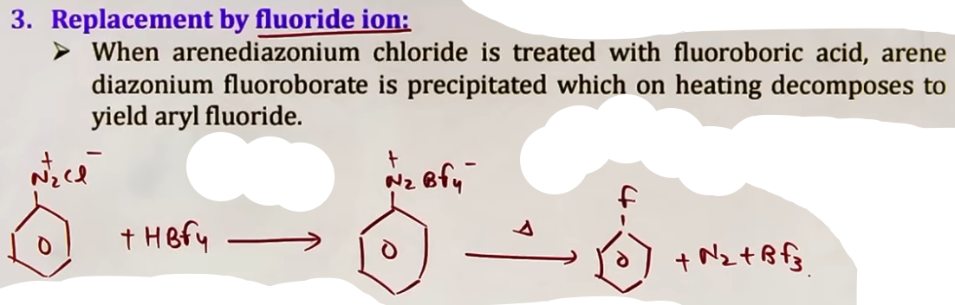
5. Reduction to Benzene:
- H₃PO₂ + H₂O → C₆H₅H + H₃PO₃ + N₂
- CH₃CH₂OH → C₆H₅H + CH₃CHO + N₂

6. Hydrolysis (Phenol):
- H₂O (Warm/283 K) → C₆H₅OH + N₂ + HCl

7. Replacement by NO₂:
- HBF₄ then NaNO₂ / Cu (heat) → C₆H₅NO₂ + N₂

REACTION INVOLVING RETENTION OF DIAZO GROUP
COUPLING REACTIONS (N₂ RETENTION)
- With Phenol (pH 9-10): Ar-N₂⁺ + C₆H₅OH → p-hydroxyazobenzene (Orange Dye)
- With Aniline (pH 4-5): Ar-N₂⁺ + C₆H₅NH₂ → p-aminoazobenzene (Yellow Dye)
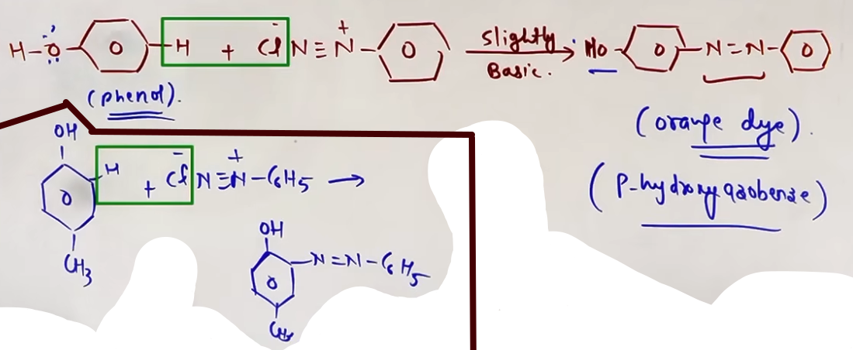# aniline m sab same h bas -OH ki jagah NH₃ hoga

---
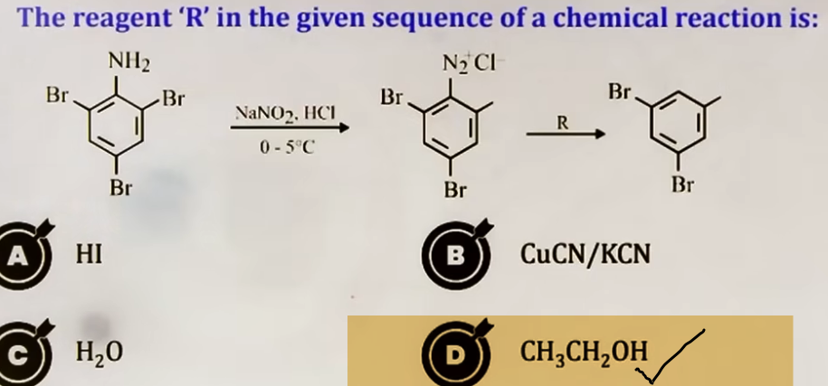
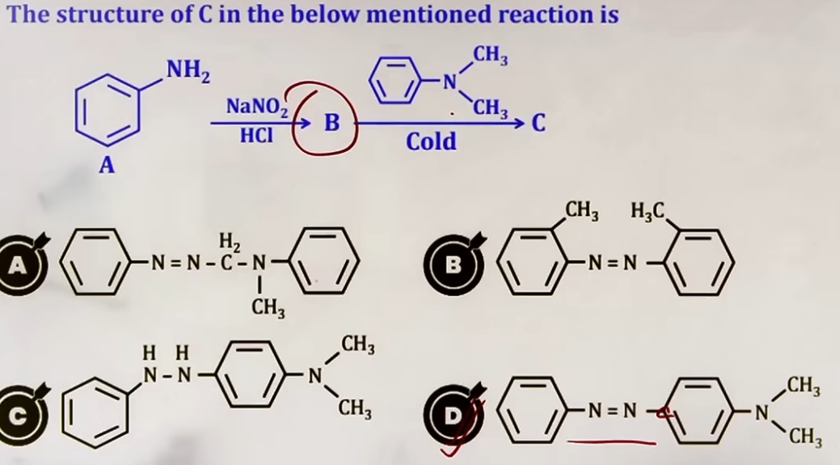
---
CONCEPT CONNECTIONS
+---------------------+-------------------------------------------+
| Property / Reaction | Connection to Other Topics |
+---------------------+-------------------------------------------+
| Stability | Resonance (General Organic Chemistry) |
| Sandmeyer | Nucleophilic Substitution (Aryl Halides) |
| Balz-Schiemann | Specific method for Fluoro-aromatics |
| Coupling | Electrophilic Aromatic Substitution (EAS) |
| N₂ Gas Evolution | Diagnostic test for primary amines |
+---------------------+-------------------------------------------+

JEE ADVANCED INSIGHTS

ELECTROPHILIC NATURE
The diazonium ion (Ar-N₂⁺) acts as a weak electrophile in coupling reactions. It is not strong enough to attack simple benzene; it needs a highly activated ring like Phenol or Aniline to react.

COUPLING SELECTIVITY
Coupling always takes place at the para position with respect to the activating group (-OH or -NH₂). If the para position is blocked, it occurs at the ortho position.

H₃PO₂ VS ETHANOL
In the reduction to benzene, H₃PO₂ is oxidized to phosphorous acid (H₃PO₃), while Ethanol is oxidized to Acetaldehyde (CH₃CHO). Both acts as reducing agents for the diazonium salt.

HIGH-YIELD REVISION SHEET

MUST REMEMBER:
- Preparation: Aniline + NaNO₂ + HCl (0-5°C).
- Sandmeyer: Cu(I) salts; Gattermann: Cu powder.
- Iodine: Use KI (no catalyst needed).
- Fluorine: Balz-Schiemann using HBF₄.
- Reduction: H₃PO₂ or Ethanol.
- Hydrolysis: Warm water → Phenol.
- Coupling: Diazonium + Phenol → Orange dye (Basic pH).
- Coupling: Diazonium + Aniline → Yellow dye (Acidic pH).

LAST-MINUTE REVISION POINTS:
- Aliphatic 1° amines produce N₂ gas and alcohol; they do not form stable salts.
- The -N₂⁺ group is meta-directing and deactivating if left on the ring (before displacement).
- Diazonium salts are the best intermediates for introducing -F, -I, -CN, and -OH groups into the benzene ring.
- Coupling is an example of an Electrophilic Aromatic Substitution (EAS) reaction.
--------------------------------------------------------------------------------

OTHER/ADDITIONAL NAME REACTIONS: CURTIUS AND SCHMIDT REACTIONS {not so imp}

Both reactions are methods to prepare primary amines (1°) from carboxylic acid derivatives. They are closely related to the Hoffmann Bromamide Degradation because they involve the same key intermediate: Alkyl Isocyanate (R-N=C=O).

A. CURTIUS REACTION
In this reaction, an acyl chloride (R-COCl) is treated with sodium azide (NaN₃).
- Step 1: Nucleophilic substitution occurs where the azide ion (N₃⁻) replaces the chloride to form an Acyl Azide (R-CON₃).
- Step 2: Upon heating, the acyl azide undergoes rearrangement with the loss of Nitrogen gas (N₂) to form Alkyl Isocyanate (R-N=C=O).
- Step 3: Hydrolysis of the isocyanate yields a primary amine (R-NH₂).
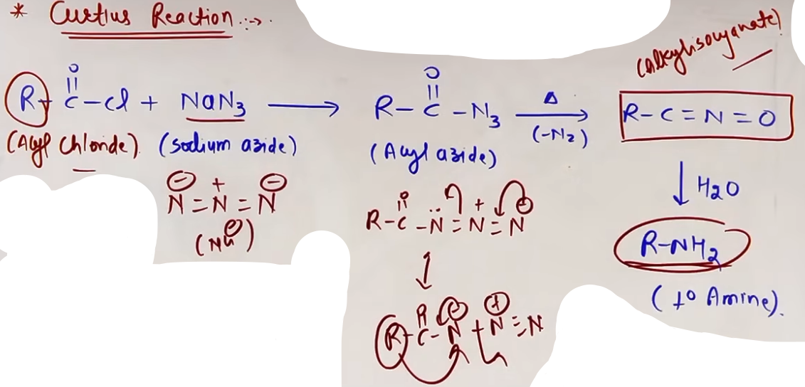
B. SCHMIDT REACTION
This involves the reaction of a carboxylic acid (R-COOH) with hydrazoic acid (N₃H) in the presence of concentrated H₂SO₄.
- Like the Curtius reaction, it proceeds via an alkyl isocyanate intermediate.
- The final product is a primary amine with one less carbon atom than the starting acid.
- (Warning) Do not confuse Sodium Azide (NaN₃) used in Curtius with Hydrazoic Acid (N₃H) used in Schmidt.
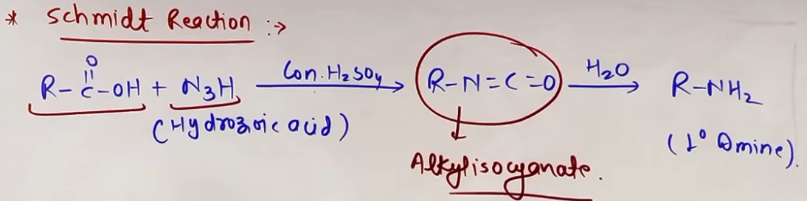
INTUITION AND CONCEPTUAL UNDERSTANDING
Think of these reactions as "carbon-cutting" tools. Just like Hoffmann Bromamide, you are removing the carbonyl carbon (C=O) and attaching the R group directly to the Nitrogen. The "engine" that drives these reactions is the extremely high stability of the N₂ gas that leaves during the rearrangement.

+=========================================================+
| Curtius: R-COCl + NaN₃ (heat) + H₂O → R-NH₂ + N₂ + NaCl |
| Schmidt: R-COOH + N₃H (conc. H₂SO₄) → R-NH₂ + CO₂ + N₂ |
+=========================================================+

C. HOFFMANN ELIMINATION (ANTI-SAYTZEFF/HOFMANN PRODUCT)
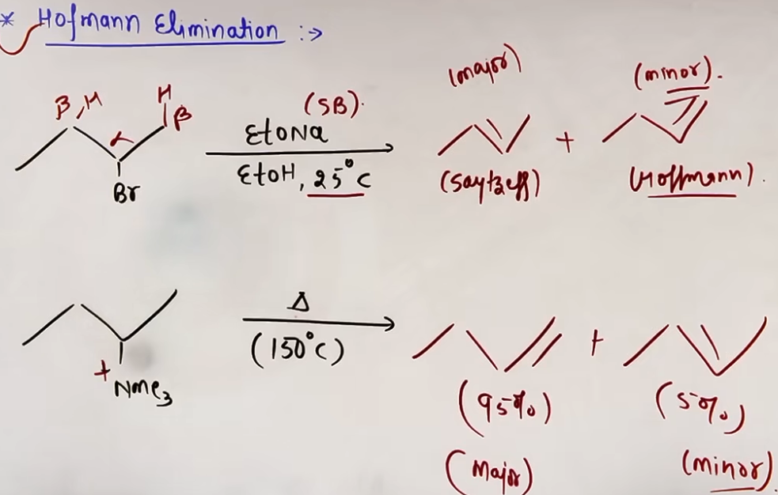
In standard elimination reactions (E2) of alkyl halides, the more substituted alkene (Saytzeff product) is usually the major product. However, in the elimination of quaternary ammonium salts (R₄N⁺ X⁻), the trend is reversed.

D. HOFFMANN MUSTARD OIL REACTION
This is a diagnostic test used to identify primary (1°) amines.

REAGENTS AND PROCESS
- Reactants: 1° Amine (Aliphatic or Aromatic) + Carbon Disulphide (CS₂).
- Follow-up Reagent: Mercuric Chloride (HgCl₂).

OBSERVATION
- Product: Alkyl Isothiocyanate (R-N=C=S).
- Smell: The product has a characteristic smell of Mustard Oil.
- By-product: A black precipitate of Mercuric Sulphide (HgS) is formed.
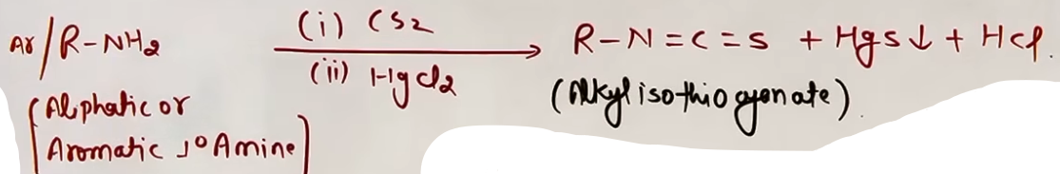
E. REDUCTION OF NITROBENZENE IN DIFFERENT MEDIA
The reduction of Nitrobenzene (C₆H₅NO₂) is highly sensitive to the pH of the medium. The final product changes depending on whether the conditions are acidic, neutral, or basic.
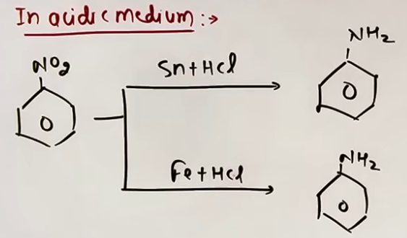
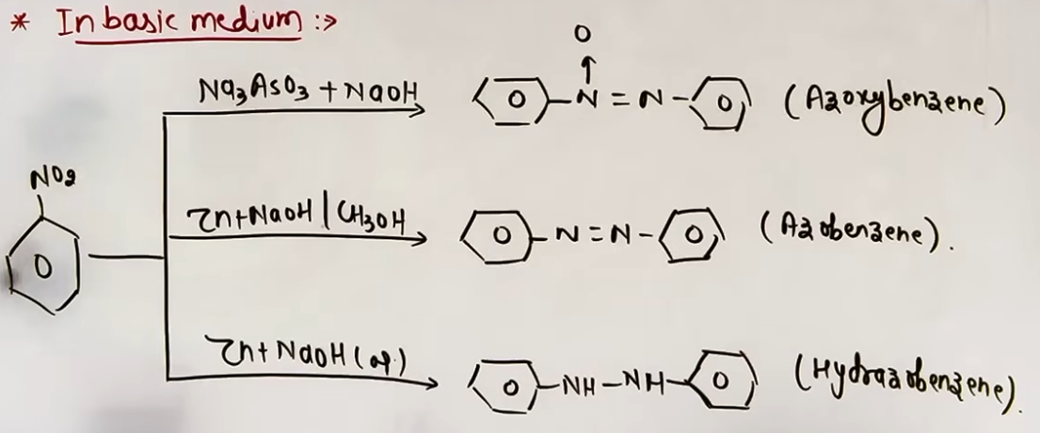
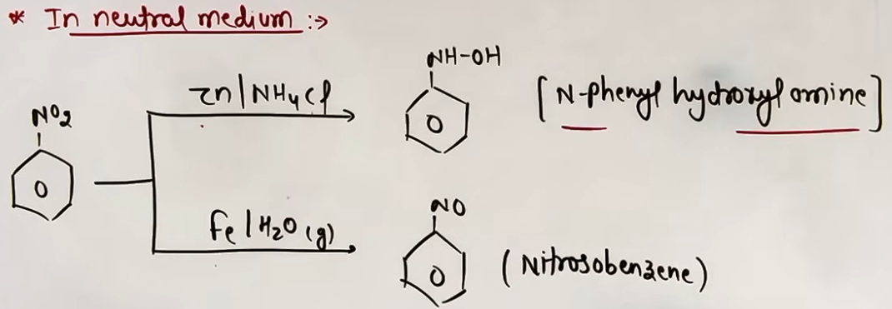

F. REDUCTION WITH LiAlH₄
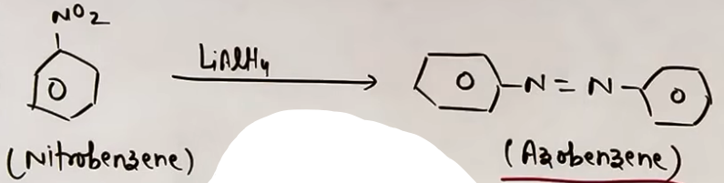
G. ELECTROLYTIC REDUCTION
- Slightly Acidic (Dilute H₂SO₄): Yields Aniline.
- Strongly Acidic (Conc. H₂SO₄): Initially forms Phenylhydroxylamine, which immediately undergoes rearrangement to form Para-aminophenol (HO-C₆H₄-NH₂).

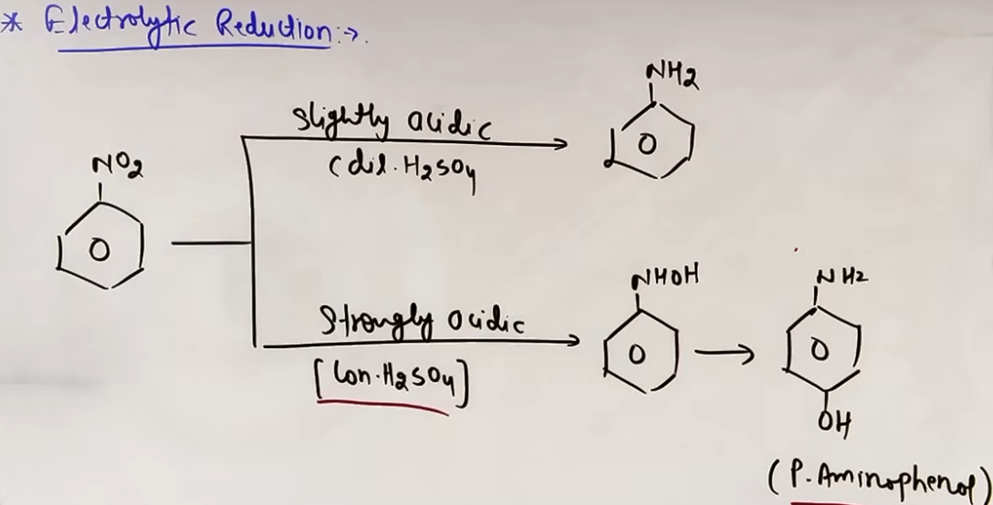

PROBLEM-SOLVING FRAMEWORK
Question Type | Identification Clues | Approach / Strategy | Common Mistakes
Identify 1° Amine | Mustard oil smell / Black ppt | Hoffmann Mustard Oil Test (CS₂ + HgCl₂). | Thinking 2° or 3° give the test.
Alkene Product | Quaternary salt + Heat | Form the LEAST substituted alkene. | Picking the Saytzeff product.
Medium effect | Nitrobenzene + Zn/NH₄Cl | Neutral medium = Hydroxylamine product. | Writing Aniline as product.
Amide to Amine | Carbonyl removal | If C is lost: Hoffmann Bromamide. If C stays: LiAlH₄. | Swapping the reagents.

JEE ADVANCED INSIGHTS AND RANK-IMPROVING TIPS

HIDDEN OBSERVATIONS
- In Hoffmann Elimination, the leaving group ability and steric bulk are the deciding factors. If the leaving group is neutral (like in alkyl halides), Saytzeff is preferred. If it is charged (like -NR₃⁺ or -SR₂⁺), Hofmann is preferred.
- In the reduction of nitro compounds, Fe/HCl is preferred over Sn/HCl because FeCl₂ hydrolyzes to regenerate HCl, making it more economical.
- Many preparation methods (Gabriel, Hoffmann Bromamide, Curtius, Schmidt) are restricted to primary amines only.

TEACHER'S SUMMARY TIPS
- Name Reactions are King: Focus heavily on Hoffmann Bromamide, Gabriel Phthalimide, and Carbylamine tests.
- Basicity is Vital: Understand the aqueous phase basicity orders (213 and 231) thoroughly, as they are frequently tested in JEE Main.

HIGH-YIELD REVISION SHEET
MUST REMEMBER:
- Curtius/Schmidt Intermediate: Alkyl Isocyanate (R-N=C=O).
- Hoffmann Elimination: Least substituted alkene is Major.
- Mustard Oil Test: 1° Amine + CS₂ + HgCl₂ → R-NCS (Mustard smell) + HgS (Black).
- Nitrobenzene + Zn/NH₄Cl → C₆H₅NHOH (Neutral).
- Nitrobenzene + Conc. H₂SO₄ (Electrolytic) → p-aminophenol.

LAST-MINUTE REVISION POINTS:
- NaNO₂ + HCl at > 5°C → Phenol (from Aniline).
- Fe/HCl is better than Sn/HCl.
- 1° Aliphatic amines + HNO₂ → Alcohol + N₂ (Carbocation shift possible).
- Hinsberg Reagent: 1° (Soluble), 2° (Insoluble), 3° (No reaction).

$$$$$$$$$$$$$$$$$$$$$$$$$$$$$$$$$$$$$$$$$$$$$$$$$$$$$$$$$$$$$$$$$$$$$$$$$$$$$$$$

- organic m kahin bhi agar KOH k sath CHCl3 mil jaye toh sabse pehle dhyan reimen-tiemann par ya carbylamine test p.

